Basic Logic Gate Simulation
Description:
A simple project to simulate basic logic gates (AND, OR) using switches as inputs and LEDs as outputs. This project helps in understanding how digital logic gates work in practical hardware form.
Block Diagram:
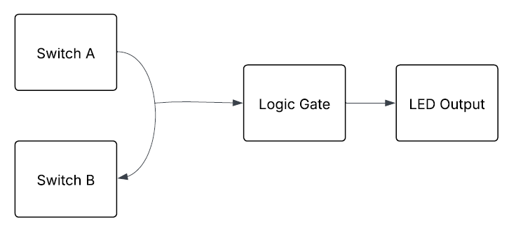
Pinout / Circuit Connection:
- LED 1 → Digital Input Pin 2 on Arduino
- LED 2 → Digital Input Pin 3 on Arduino
- Resistors (10kΩ pull-down) → connected to each switch input
- LED (for AND gate output) → Digital Pin 7 (with 220Ω resistor)
- Power Supply → USB cable or external 5V supply for Arduino
Components Required:
- Arduino UNO (or compatible) – microcontroller board
- 2 x LEDs – for inputs
- 1 x LEDs (Red/Green) – for AND output
- 2 x 220Ω resistors – current limiting for LEDs
- 2 x 10kΩ resistors – pull-down resistors for switches
- Breadboard – for assembling circuit
- Jumper Wires – for connections
- USB Cable / 5V Power Supply – to power Arduino
Working Principle:
The switches represent binary inputs (0 or 1). The Arduino reads the switch states and computes the AND logic in software. Depending on the logic result, the respective LED (AND or OR) lights up.
Operation (Step-by-Step):
- Power ON the Arduino using USB or battery.
- Switches are used as inputs (0 = OFF, 1 = ON).
- Arduino reads the digital state of both switches.
- For AND Gate: LED glows only when both switches are ON.
- For OR Gate: LED glows when any one or both switches are ON.
- This demonstrates the basic working of logic gates.
Arduino Code:
int inputA = 2;
int inputB = 3;
int outputLED = 8;

void setup() {
pinMode(inputA, INPUT_PULLUP);
pinMode(inputB, INPUT_PULLUP);
pinMode(outputLED, OUTPUT);
}

void loop() {
int A = !digitalRead(inputA); // Inverted due to pull-up
int B = !digitalRead(inputB);

// AND Logic
if (A == 1 && B == 1) {
digitalWrite(outputLED, HIGH); // Output = 1
} else {
digitalWrite(outputLED, LOW); // Output = 0
}
}Conclusion: (Predefined/self-written)
The Basic Logic Gate Simulation project is an easy and effective way to understand how logic gates like AND and OR function. Using switches and LEDs makes it visually clear for students and beginners.
For Your References:
[1] Arduino, “Arduino Digital Read Documentation,” Arduino.cc, [Online]. Available: https://www.arduino.cc/en/Reference/DigitalRead. [Accessed: 12-Sep-2025].
[2] Electronics Tutorials, “Logic Gates Tutorial,” Electronicstutorials.ws, [Online]. Available: https://www.electronics-tutorials.ws/logic/logic_1.html. [Accessed: 12-Sep-2025].

